


Project Name

Project Plan

Version

Revision History

Date | Version | Description | Author
2002-00-00 | 0.01 | Initial Draft

Table of Contents
1.Introduction 4
1.1Purpose of this document 4
1.2Intended Audience 4
1.3Scope 4
1.4Definitions and acronyms 4
1.4.1Definitions 4
1.4.2Acronyms and abbreviations 5
1.5References 5
2.Background and Objectives 5
3.Organization 5
3.1Project group 5
3.2Customer 6
3.3Supervisor 6
4.Development process 6
4.1General Overview 6
4.2First Phase of Project 7
4.3Three Packets of Product-Development 7
4.4Quality assurance 7
5.Inputs 7
5.1.1Remarks 7
6.Project risks 8
7.Communication 9
8.Configuration management 9
9.Project plan 9
9.1Time schedule 10
9.1.1Remarks 10
9.2Activity plan 10
9.2.1Remarks 13
10.Deliverables 13
10.1.1Remarks 13

Introduction

Purpose of this document

The purpose of this document is to assist in the planning of the development of the project 'Real-Time Bridge Monitoring”, as a part of the Distributed Software Development course. This document will be the starting point and first deliverable of the project. It is essential for the beginning phase of the development process, and will be slightly updated throughout the whole project.

Intended Audience

This document is written primarily for the development team. The crucial planning decisions will be recorded in this document, so the development team will use it as a guidance while planning their time, splitting tasks and it will serve as a basis for the next phases of the project.
Also, this document is intended for the supervisors, in order to give them insight into our initial view and plan of the project.

Scope

This document will have main focus on the organization of the team and planning and distribution of work during the development process.

Firstly, the background and objectives of the project will be briefly explained.

After that, the organization within the team will be shown, regarding the distribution of work and responsibilities of each team member. Also, the stakeholders of the project will be introduced.

The development process that will be used in the development of the system will be presented in the fourth section. Here there will also be a brief description of each increment of the system.

Each deliverable will be described in the sixth section. This part will be updated throughout the project in order to record the delivered products and documents, and passed deadlines.

Further on, the inputs to the system will be presented. The inputs present the data that will be received from the customer and be processed by the system.

The document will also cover communication tools and conventions that we have agreed upon. In this chapter, it will be described in details how the information flow should look like.

Finally, configuration management and the project plan will be introduced. The project plan will cover the main planning decisions main about the project, regarding time, milestones, activities. This plan will be represented in an intuitive way, by using tables, charts and gantt-charts with timestamps.

Definitions and acronyms

Definitions

Keyword | Definitions

Acronyms and abbreviations

Acronym or  abbreviation | Definitions

References

Background and Objectives
Describe (in general) goals of the project. Describe (in general) project requirements, milestones, deliverables, testing, product delivery.

Organization
Describe project composition (team members, distribution of team members, roles defined in the project team. State tools used to support the development process (emphasize should be on tools supporting project management, collaboration, not development tools such as Eclipse, C compiler …)

Project group

The project group consists of seven members all together. There are three members from the Italian side, that are coming from the Politecnico di Milano University: Andrea Bottoli, Lorenzo Pagliari and Marko Brcic. The other four members are from the Mälardalens University: Dzana Kujan, Miraldi Fifo, Jorn Tillmanns and Nikola Radisavljevic. Their roles in the group are defined and represented in the table below.

Name | Initials | Responsibility (roles)
Andrea Bottoli | AB | Project Manager
Dzana Kujan | DK | Team Leader
Marko Brcic | MB | Documentation manager
Lorenzo Pagliari | LP | Design manager
Miraldi Fifo | MF | Testing manager
Jorn Tillmanns | JT | Database manager
Nikola Radisavljevic | NR | Integration manager

Customer

There are two customers in this project. They are Ballio Francesco and Crotti Gianluca.

Supervisor

There are two supervisors in this project. They are Mirandola Raffaela and Di Nitto Elisabetta.

This organization structure is better depicted in the following picture.

Development process

In this section, the development process will be explained in details.

General Overview
We will use elements from the waterfall and incremental development process in order to fulfill both the requirements of the customer and the course. The documentation will be delivered in a waterfall kind of way, sequentially. However, the requirements and design phase will be distributed throughout the whole project, with multiple increments of the system being delivered after a certain amount of time.

First Phase of Project
In the first phase of our project we will focus to prepare the Implementation and build a good basis for later work. For this we have the two main aspects, the analysis of requirements and the design of the system. In this phase we will organize the project sequential as known from the waterfall model.

Three Packets of Product-Development
In the waterfall model the phase of system design is normally followed by the Design of the Program. At this point we want to leave the normal waterfall model and choose a incremental model. Instead of only on phase of program design, implementation and testing, we bundle this three phases to a packet and repeat this packet three time. After the first bundle of program design, implementation and testing, we will be able to deliver the customer the first alpha prototype.

Quality assurance
Because of the mix between the classical Waterfall model and an incremental development process. we are able to provide a high quality during this project. During the first stage we will figure out what we have to do and in witch way we will solve the problem. In this phase the contact with the customer is very important.
After the next phase we provide the alpha prototype. So the customer has the possibility to see the direction of the development.. The same is after the beta prototype.
In the last stage, we planed the last two weeks for testing and bug fixing. So we could be able to deliver a product with best quality.

Inputs
Fill the table with inputs (artifacts required to complete your project, but out of your control – for example library developed by another project, example data provided by the project customer etc.). During the project track whether the inputs have been delivered on time. Include inputs in risk table and try to develop preventive actions and strategies in case inputs are late or never delivered.
From | Required item | Planned week | Promised week | Late +/- | Delivered week | Rem

Comment: Required week = week when it is required by the project; Promised week indicates when the From expects to deliver; Late + indicates a discrepancy between Required week and Promised week; Received week is week when it was actually received; Rem is a remark index number.

Remarks

Remark Id | Description

Project risks

There are several risks that can affect the productivity of the team members and the accuracy of the final result of this project. Therefore, it is essential to be analyze the possibility of each risk happening, and to come up with a preventive action for each risk early in the project. This will increase the possibility of producing a high quality product and dealing with problems easier. In the table below, risks are listed, along with their possibility and preventive actions.

Possibility | Risk | Preventive action
H | Poor communication with the customer | Try to insist on more frequent meetings with the customers.
H | Undefined date for receiving input data | Try to insist on receiving it as soon as possible.
H | Unclear requirements | Try to have as much contact with customer, and ask them for feedback. Get acceptance of requirements from the customer early in the project.
M | Communication within the team | Define precise roles of the team members (team manager, team leader) and define communication flow between all the sides of the team. Also, define fixed dates for group meetings.
L | Communication within the distributed groups | This will be solved by planning to have daily meetings and try to have sprints together.
L | Lack of technical background | We deal with this by choosing technologies that are widely used and well known to the team members
L | Cultural differences | Be patient and open-minded
L | Language misunderstandings | Be patient and ask a lot of questions, in order to not get a wrong understanding of what a person meant
M | Information flow – risk of now receiving all information or of receiving correct one | Work on frequent communication especially between customer-project manager, project manager-team leader
M | Losing data | Always have a back-up of all the files that have been created during the project
M | Integration problems | Good interface definitions

Communication

In this type of project when team members are phisicaly separated, setting up communication protocols turns out to be a big deal. It is important to make it clear how the information will be shared among the team members and to make sure everyone has the same picture of the project.

In our team we have three separated groups of team members. We have four team members in Vastertas(SWE), two in Milan(ITA) and one in Zagreb(CRO). According to this we have agreed to have two subgroups. The first one consist of team members from Vasteras, and second one consist of members form Milano and Zagreb.

The subteam from Milano has a project manager and team from Vasteras has a team leader. Communication between these two people will be the most frequent, they will be in touch basically all the time and try to coordinate all team members and lead the project in the right direction. Having this frequent communication between these two people, we hope we will be able to react more quickly to any unexpected problem.

The next stage of communication within the group are group meetings. We agree to have at least one weekly meeting. More meetings during the week will be organized if needed. Each group meeting will be documented in the minutes of meeting document.

Finally, meetings within subgroups will be organized on a daily bases.

As technical support for communication, Skype, Google hangout and spreadsheets will be used. For sharing documentation and code Git will be used.

Configuration management
Describe configuration mgmt. plan, coordination, tools used, backup, preventive actions and corrective actions when the system is not used properly by some team members.. Use subsections to logically divide content of this section.

Project plan

In this section, the project plan will be presented. It will include a list of all the milestones of the project along with the responsible team members associated with the milestone, and the planned week for the milestone. Also, the activity plan will be presented with a Gantt chart.

Time schedule

In the table below, the milestones are presented.

Id | Milestone description | Responsible dept./initials | Finished week |  |  |  | Metr. | Rem.
Id | Milestone description | Responsible dept./initials | Plan | Forecast |  | Actual | Metr. | Rem.
 |  |  |  | Week | +/- | Actual | Metr. | Rem.
1 | Requirements v1. | AB | 44
2 | System design | LP | 44
5 | Alpha prototype | AB | 48
6 | Beta prototype | AB | 51
7 | Final prototype | AB | 02

Remarks

Remark Id | Description

Activity plan

The activity plan is presented in the Gantt chart below. The activities and milestones are shown.

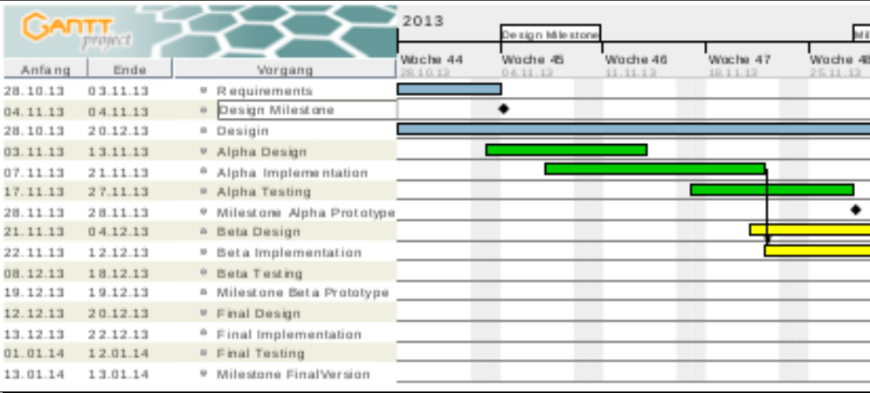

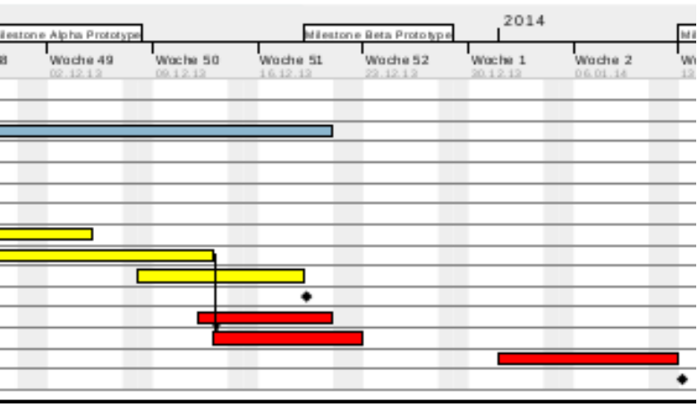

The requirements analysis is planned to be finished earlier in the project, and it is not planned to be updated much in the following prototypes. This decision was made because the customers know what they want and are not available for frequent communication with the development team.

The design activity is planned throughout the project. This is due to the fact that the design decisions will be updated in each prototype development cycle. The design document will be also constantly updated, in order to be consistent with the working prototypes at all times. The design activity includes design of database, UI design and interface design, which should all be finished before starting work on the Alpha prototype.

The product will be developed incrementally, and as a result of that, there will be three increments: Alpha, Beta and Final prototype. Each prototype contains the activity of design, implementation and testing. This will ensure high quality of each prototype.

In the alpha prototype, the basic functionalities of the system will be implemented. At the end of this increment, we will have a working product which will contain at least reading of one sensor data from the database, and presenting that data on the user interface. This will be the foundation of the following increments, and the product that we will build upon.

The beta prototype will take longer time to develop, compared to the Alpha and Final prototypes. It is because the plan is to introduce most of the functionalities in this prototype. This means that the database will be upgraded to support all sensors, and all sensor data will be available on the UI, as well as all calculation results.

The final prototype will include the finalization of requirements and will concentrate on adding minor fixes, enhancing the UI or adding low priority functionality.

In order to achieve high quality of the product, each prototype will be tested.

ID | Predecessor | Activity | Days | Mdays | Rem.
1 |  | Requirements Analysis
2 |  | System Design
3 |  | Program Design: Alpha Prototyp
4 |  | Implementation: Alpha Prototyp
5 |  | Testing: Alpha Prototyp
6 |  | Program Design: Beta Prototyp
7 |  | Implementation: Beta Prototyp
8 |  | Testing: Beta Prototyp
9 |  | Program Design: Final Version
10 |  | Implementation: Final Version
11 |  | Testing: Final Version

Total planned calendar days for the project to be finished and total planned man-days required to finish the project
Planned effort (days) | Planned effort (man-days)

Remarks

Remark Id | Description

Deliverables

In this part, the deliverables will be presented. The deliverables are divided into two groups. The first group represents the external deliverables, which have to be delivered as a part of the course Distributed Software Development, to the professors and mentors of this course. On the other side, there are deliverables that are defined by the development team. In the table below, the deliverables are stated along with the planned delivery dates.

To | Output | Planned week | Promised week | Late +/- | Delivered week | Rem
Steering group | Project plan document (v.1) | 44 | 44
Steering group | Requirements Definition document (v.1 ) | 44 | 45
Steering group | System design (v.1 ) | 44 | 45
Steering group | Acceptance test plan | 51 | 52
Steering group | Test report | 1 | 2
Steering group | Final Project Report | 2 | 2
Steering group | Final product | 2 | 2
Dev. team | Database design | 44 | 44
Dev. team | Interface design | 44 | 44
Dev. team | UI design | 44 | 44
Dev. team | System Design (v.2) | 46 | 48
Dev. team | System Design (v.3) | 49
Dev. team | System Design (v.4) | 51
Dev. team | Test of prototype Alpha | 48
Dev. team | Test of prototype Beta | 51
Dev. team | Test of final version | 2
Dev. Team | Pyscript for database import of the wind sensor | 47 | 48
Dev. Team | Servlets for generating UI for the wind sensor | 47 | 48
Dev. Team | Pyscript for database import for the remaining sensors and pictures | 50 | 51
Dev. Team | Servlets for generating UI for the remaining sensors | 50 | 51
Dev. Team | Alarm implmenetation | 50 | 51
Dev. Team | Refining UI and aditional requirements | 51 | 02

Remarks

Remark Id | Description

